2003

Problem 3

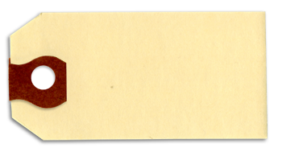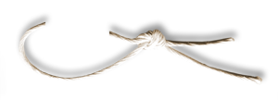

Men’s shirt sizes are determined by their neck sizes. Suppose that men’s neck sizes are approximately normally distributed with mean 15.7 inches and standard deviation 0.7 inches. A retailer sells men’s shirts in sizes S, M, L, XL, where the shirt sizes are defined in the table below.

Chapter 8 “FRAPPY”

{Free Response AP Problem...Yay!}

The following problem is taken from an actual Advanced Placement Statistics Examination.

Your task is to generate a complete, concise statistical response in 15 minutes. You will be graded based on the AP rubric and will earn a score of 0-4. After grading, keep this problem in your binder for your AP Exam preparation.

E P I

Total:__/4

|  |  |
| --- | --- |
| Shirt Size | Neck Size |
| S | 14 neck size < 15 |
| M | 15 neck size < 16 |
| L | 16 neck size < 17 |
| XL | 17 neck size < 18 |

a) Because the retailer only stocks the sizes listed above, what proportion of customers will find that

the retailer does not carry any shirts in their sizes? Show your work.

b) Using a sketch of a normal curve, illustrate the proportion of men whose shirt size is M.

Calculate this proportion.

E P I

c) Of 12 randomly selected customers, what is the probability that exactly 4 will request size M?

Show your work.

E P I